Sequence Diagram: User Requests Problem from Problem Generator
Author: Eric Koskovich
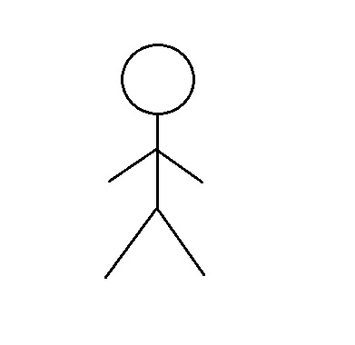
BASIC COURSE:
On the Expression Creator, the User will click program generator button. The System will create a new popup. The System will request a problem from the Problem Generator. The Problem Generator will create and return a new problem. The preview window will render an unmodifiable picture from the new Problem for the preview window. The User will click on the Replace Current Problem button. The System will move any current progress in the editor to the History and move the generated problem to the editor.

ALTERNATE COURSES:
Problem generator unable to generate problem: The System will randomly select an already existing problem from the Central Database. The System will notify an administrator.

User selects cancel button: The System will cancel the request for a preview and close the current preview window.
Expression Creator Page
Problem Generator Page
Display
ProblemGeneratorClick()
New
Problem Generator
Central Database
New
return Problem
Error generating problem
return randomly selected problem
render
(Problem)
Preview Window
New
User Selects “Replace Current Problem”
UpdateHistory
(Problem)
User Selects “Cancel”
ReplaceProblem
(Problem)
return Problem

